THEATER_________________________________________________________________

The Drowsy Chaperone Janet Van De Graaff Wildwood School
Spring Awakening Wendla Wildwood School
Rent Maureen Cats Theatre Advanced High School Production: Los Angeles
Hadestown Persephone Adderley Advanced Conservatory: Santa Barbara
Mamma Mia Donna Wildwood School
Chicago Velma Kelly Adderley Advanced Conservatory: Los Angeles
Chicago June Adderley Advanced Conservatory: Santa Barbara
Urinetown Hope Cladwell Wildwood School
You Can’t Take It With You Alice Wildwood School
Matilda Matilda Wildwood School
Twelfth Night Feste Wildwood School
Evita Ensemble Stagedoor Manor: New York

TRAINING___________________________________________________________________

University of Michigan MPulse Summer Institutes MPulse Musical Theatre Workshop 2026
SUTE: Summer University Theater Experience Musical Theatre Track - Seniors 2026
Carnegie Mellon MT Pre-College Summer Program Pre-College Music Theater Program 2025
Boston Conservatory At Berklee Summer Program Musical Theater Acting Intensive 2024
Open Jar Institute New York Broadway Intensive 2024
Ruskin School Of Acting – Amy Ruskin Meisner Technique 2023-2024

DANCE______________________________________________________________________

Natalie Iscovich Theater Jazz The Artist Collective LA and Private 2023-Present
Sabrina Harper Fosse Technique/Jazz Momentum Dance SB / LA Dancefit 2023-2025
Rocker Verastique Ballet Carnegie Mellon Summer 2025
Danny Herman Tap Carnegie Mellon Summer 2025

VOCAL TRAINING_____________________________________________________________

Bob Garrett Vocal Coach 2022-Present
Natalie Weiss Private Voice Lessons 2026-Present
Gary Kline Masterclass and Individual Instruction 2025 and 2026
Cynthia Kortman Westphal Masterclass: Professional School for the Arts Los Angeles 2025

ARTS RELATED COMMUNITY INVOLVEMENT________________________________________

Ivy Park Assisted Living & Memory Care Singing Entertainment Volunteer
Pacific Resident Theater of Venice Internship At Non-Profit Theater Company
Founder and Instructor, DC Studio Tap Instructor, Vocal and Audition Coach: Ages 11-16
Wildwood Middle School Choreographer - Pippin

COMPETITIONS/AWARDS______________________________________________________

Drama Teachers Assoc. of Southern California (DTASC)
DTASC: The Country Wife & Hadestown “Flowers” 1st Place Winner Solo Monologue 2024
AVPA Pitch Fest Short Film, Sony Films: The M Word Final Honoree – Actress, Juliet 2026

SPECIAL SKILLS AND INTERESTS_________________________________________________
Singer / Songwriter, Guitar (5 Years), Ukulele, Piano, Multi-Sport Athlete

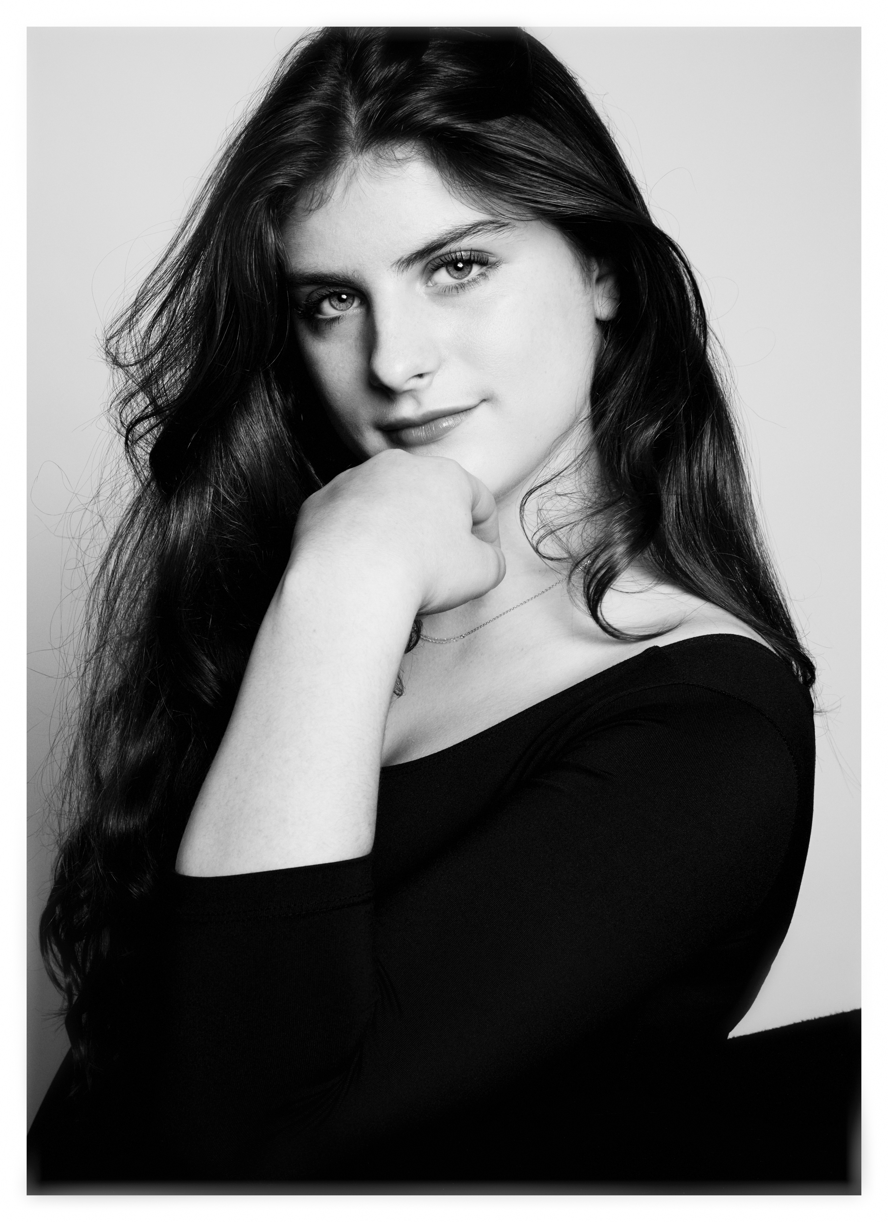

DEIA CLARA CAMPODONICO

deiaccxo@gmail.com 310/849-0599 https://deiacampodonico.com

Eyes: Green Hair: Brown Height: 5’5” Mezzo: F3 - G5 | Soprano to A5

